# Grissom High School – SECOND FLOOR

**Freshman Academy**

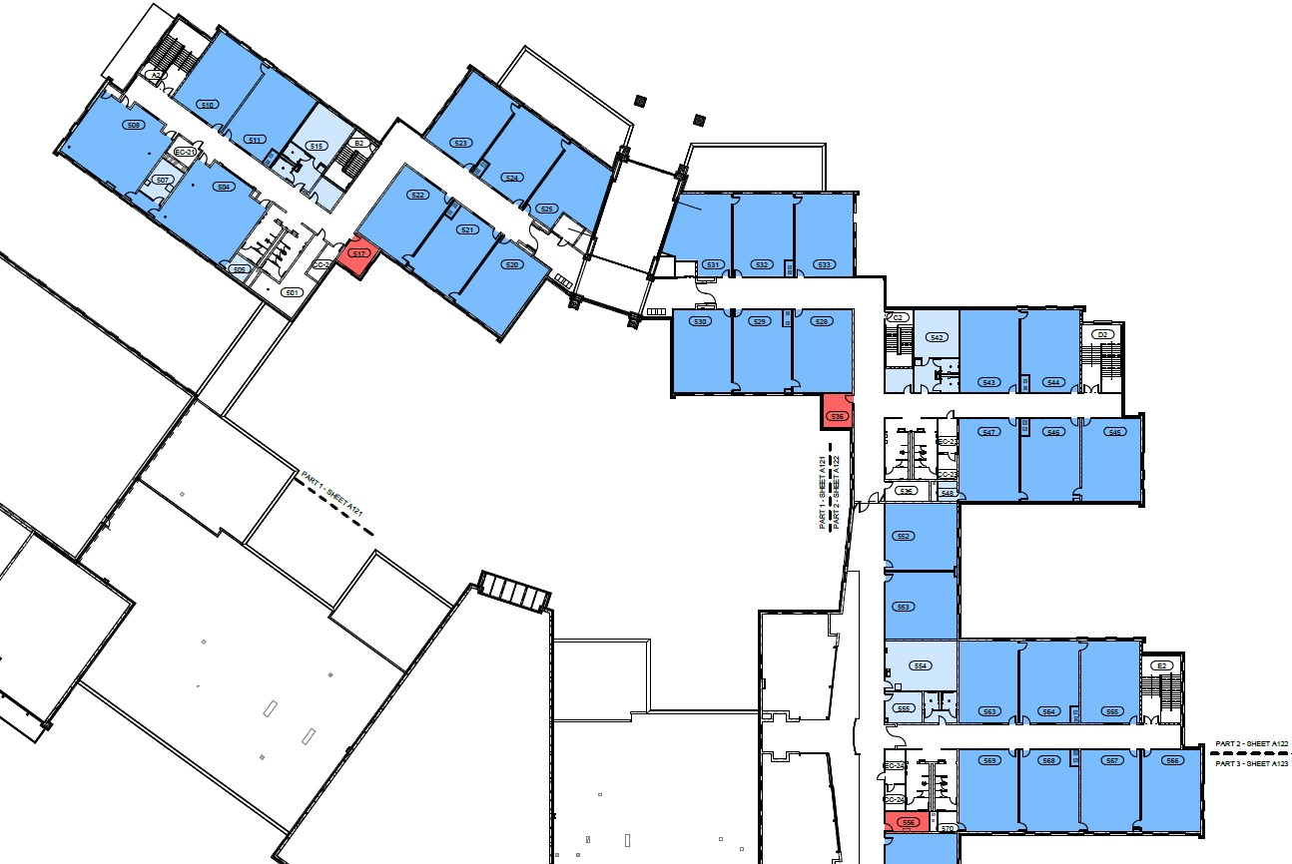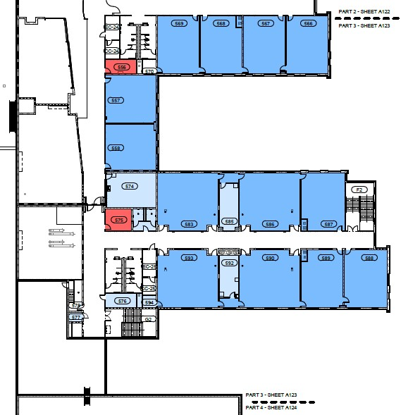

Room #:

2543

–

2547

**TIGER HALL UPSTAIRS**

Room #:

2583

–

2590

Room #:

2563

–

2569

Room #:

2528

–

2533

Room #:

2504

–

2511

Room #:

2520

–

2525

# Grissom High School – FIRST FLOOR

WALK AROUND

PARK HERE

SIGN IN HERE

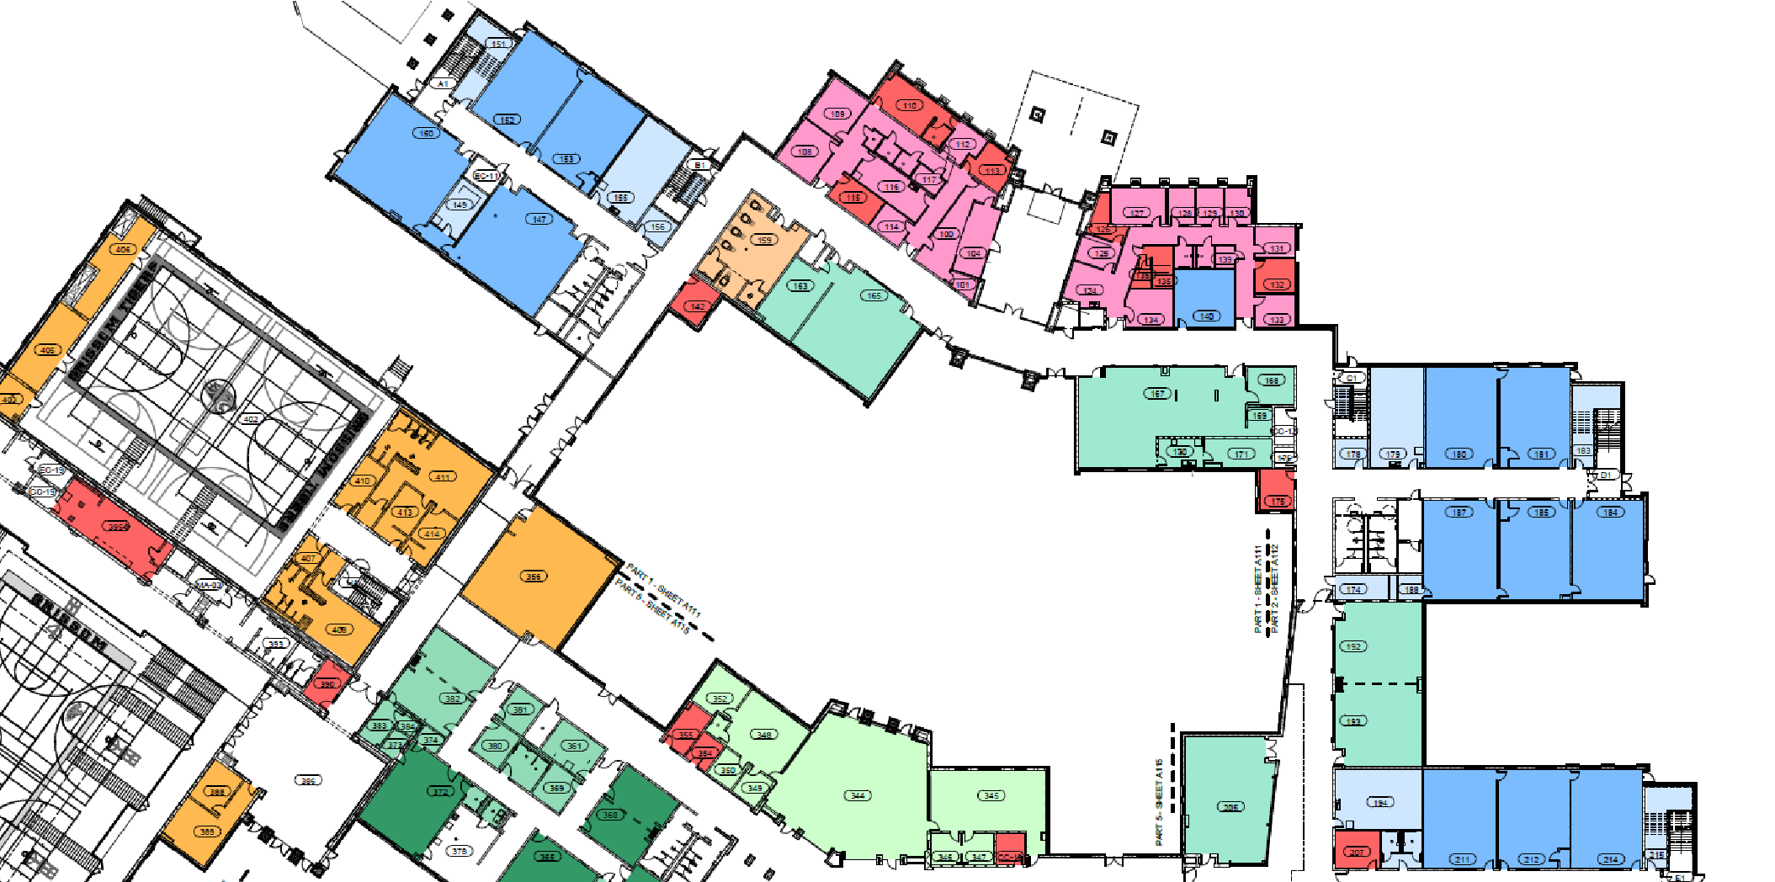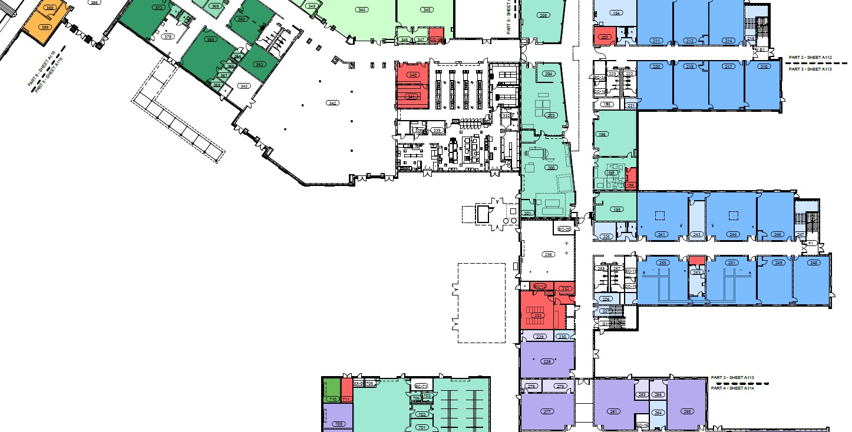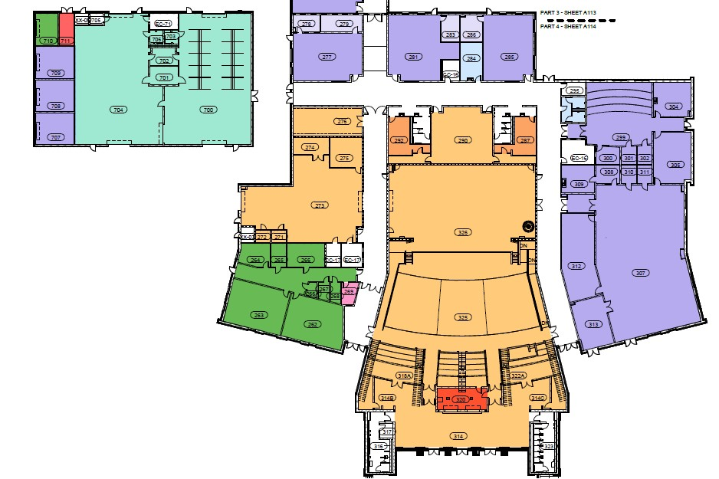

**Auditorium**



**Choir/Band**

**STUDENT**

**ENTRANCE**

**Main**

**Office/Guidance**

**STUDENT**

**ENTRANCE &**

**ATTENDANCE**

**OFFICE**

**JROTC**

**Precision**

**Machining**

**& Welding**

Room #:

1700

–

1704

**Main Gym**

**Aux**

**Gym**

**Media Center**

**Cafeteria**

**SPECIAL**

**NEEDS**

**ENTRANCE**

**Freshman**

**Academy**

**TIGER HALL**

**DOWNSTAIRS**

Room #:

1147

–

1153

Room #:

1241

–

1255

Room #:

1211

–

1220

Room #:

1180

–

1187

Room #:

1228

–

1290

Room #:

A

1356

–

B

1356